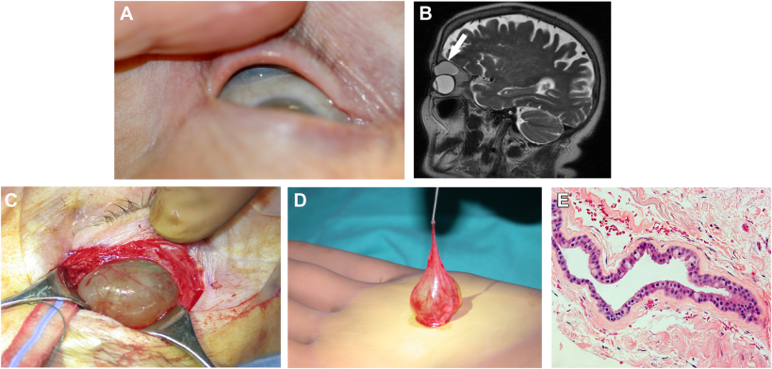

An 81-year-old woman reported double vision on upgaze. Ocular history was notable for bilateral cataract extraction. She had limitationof elevation of the right eye with ptosis. Slit-lamp examination revealed a bluish lesion under the right upper eyelid (A). Magnetic resonanceimaging demonstrated a slightly dark T2 hyperintense lesion molded over the eyeball (B, arrow). Intraoperatively, the lesion was found tobe a stretchable fluid-filled cyst (C, D).The pathological examination is as shown in the figure (E).. Based on the provided images and clinical description please make an ophthalmic diagnosis for this patient. And output the diagnostic conclusions only.

**Ophthalmic diagnosis: Orbital epithelial cyst (likely dacryops)**